**Ex. No: 9 Date: 06-12-21**

**STRUCTURES**

**PROBLEM GIVEN:**

Write a program to create a structure for storing the customer details. Use appropriate data types to store the data (arrays, strings etc). Extend the previous program to implement the same.

**ALGORITHM:**

Step 1: Start

Step 2: Declare necessary variables, pointer variables and structure variables.

Step 3: Read number of customers from the user.

Step 4: Introduce a for loop to enter customer id, customer name and vehicle cost and store it in the structure variable.

Step 5: Display all the details stored in the structures using a for loop.

Step 6: Stop

**FLOWCHART:**

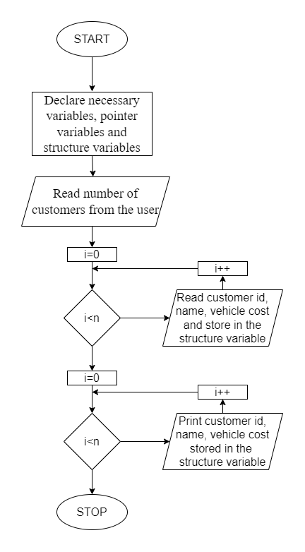

**PROGRAM:**

#include <stdio.h>

#include <stdlib.h>

struct customer{

int cid;

char name[10];

float vcost;

};

int main(){

int i, j, n;

struct customer customers[10];

struct customer *q, *customern;

q = (struct customer *) malloc(sizeof(struct customer));

printf("Enter number of customers : ");

scanf("%d", &n);

for(i=0;i<n-1;i++){

printf("Enter Customer ID, customer name and Vehicle cost : ");

scanf("%d %s %f", &customers[i].cid, customers[i].name, &customers[i].vcost);

}

printf("Enter Customer ID, customer name and Vehicle cost : ");

scanf("%d %s %f", &q->cid, q->name, &q->vcost);

for(i=0;i<n-1;i++){

printf("Name = %s\nCustomer Id = %d\nVehicle cost = %.2f\n\n", customers[i].name, customers[i].cid, customers[i].vcost);

}

printf("Name = %s\nCustomer Id = %d\nVehicle cost = %.2f\n\n", q->name, q->cid, q->vcost);

return 0;

}

**OUTPUT:**

